**→ Bilateral denoising filter :**

1. **Read our images :**

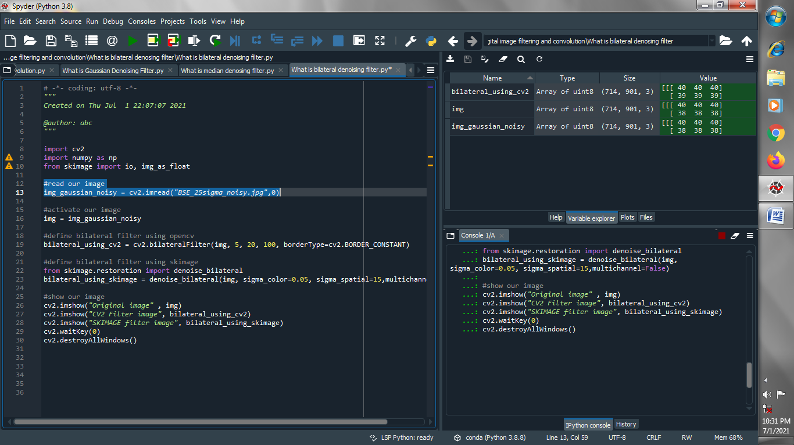

1. **Activate our image with short name :**

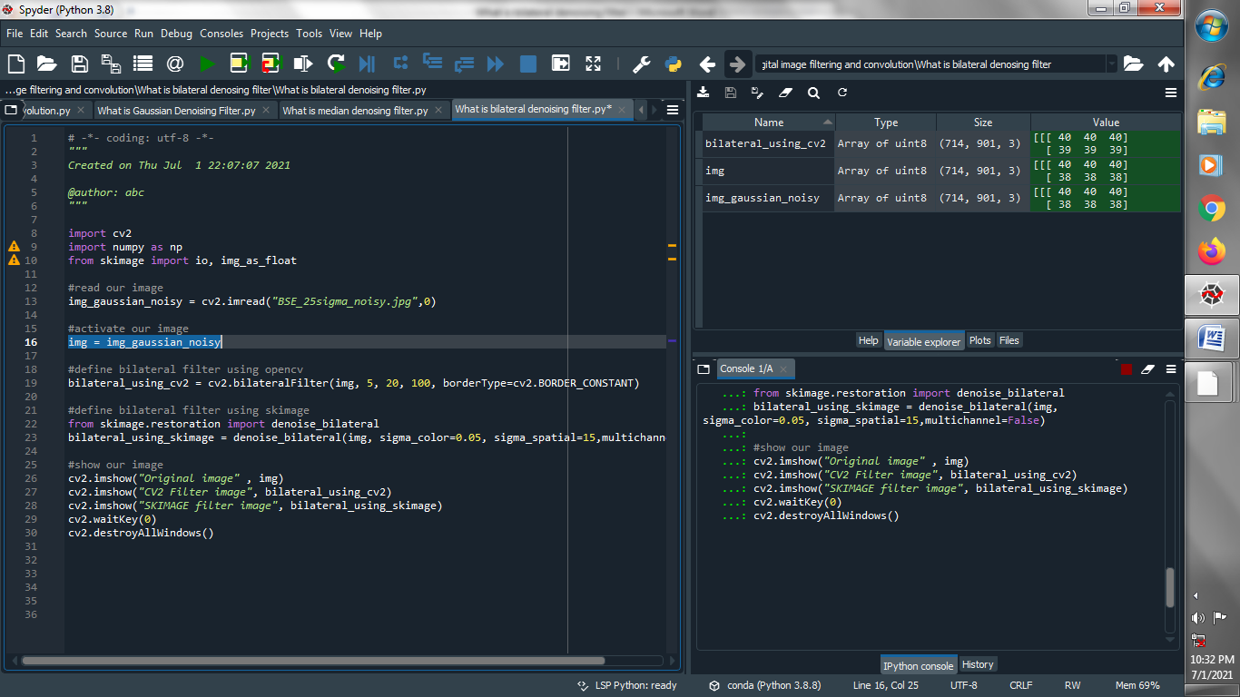

1. **Define bilateral filter using opencv :**

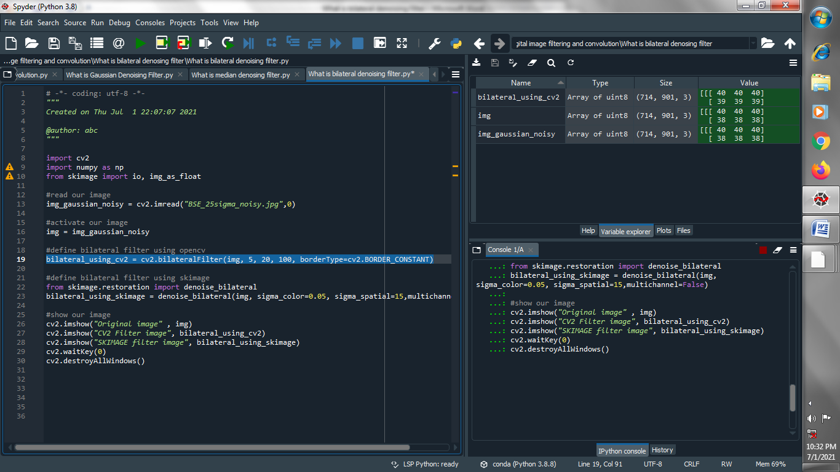

1. **Define bilateral filter using skimage :**



1. **Define bilateral filter using skimage :**

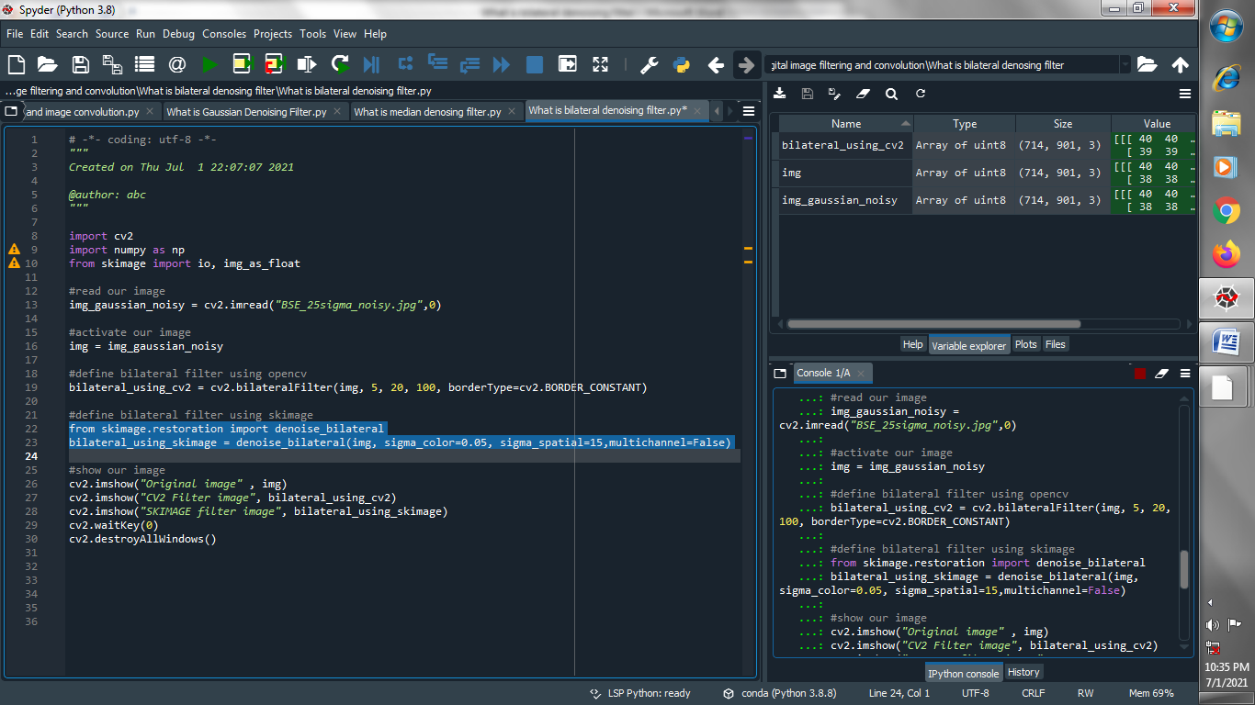

1. **Show our images :**

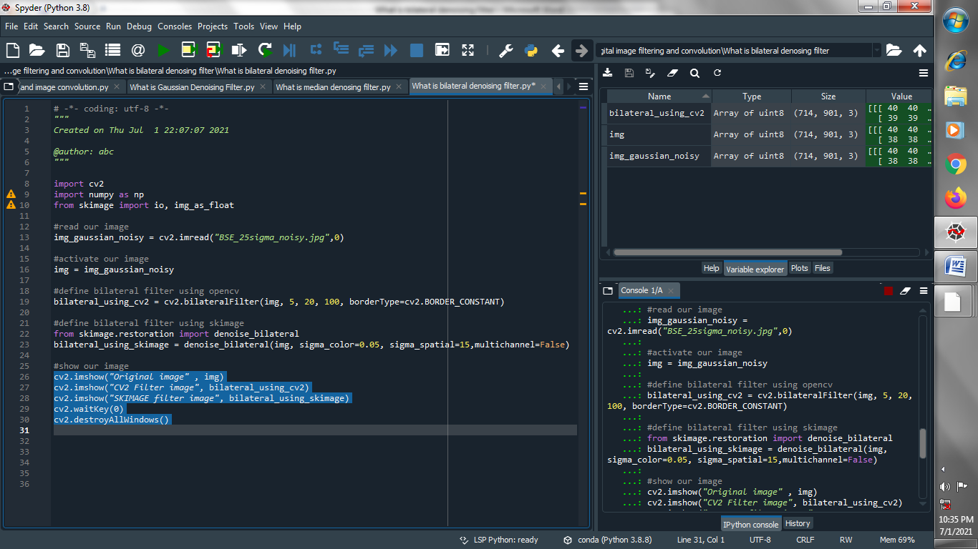

**Output :**

**Original image :**

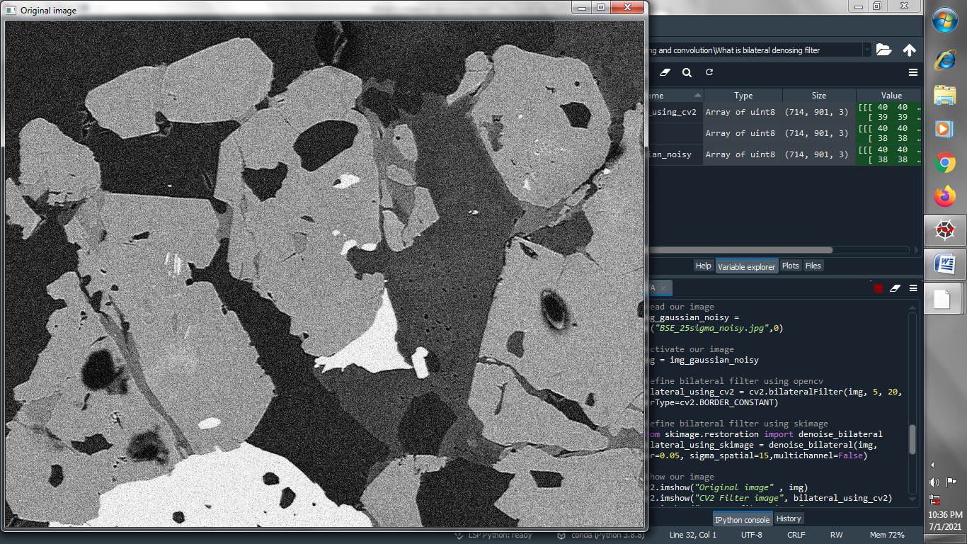

**Bilateral filtered image using opencv :**

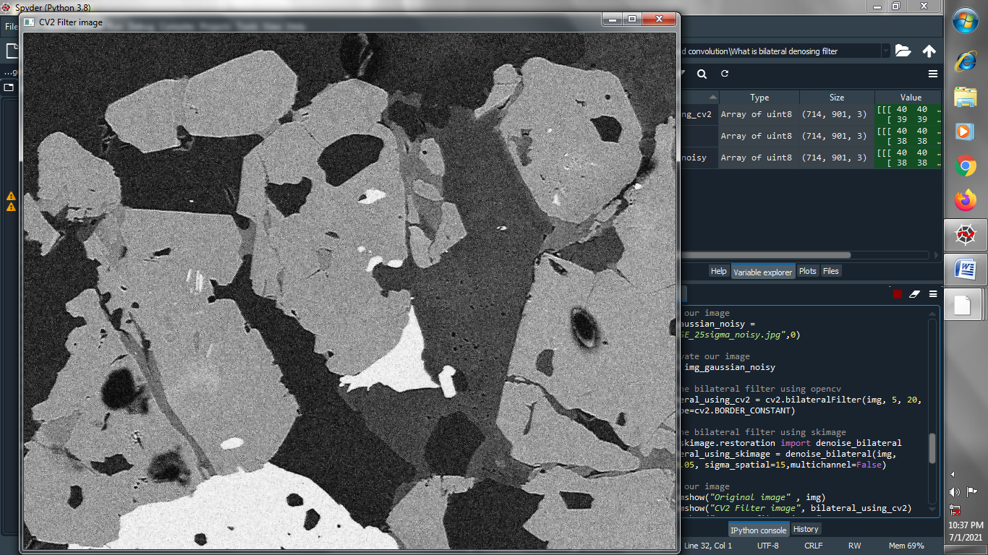

**Bilateral filter using skimage :**

